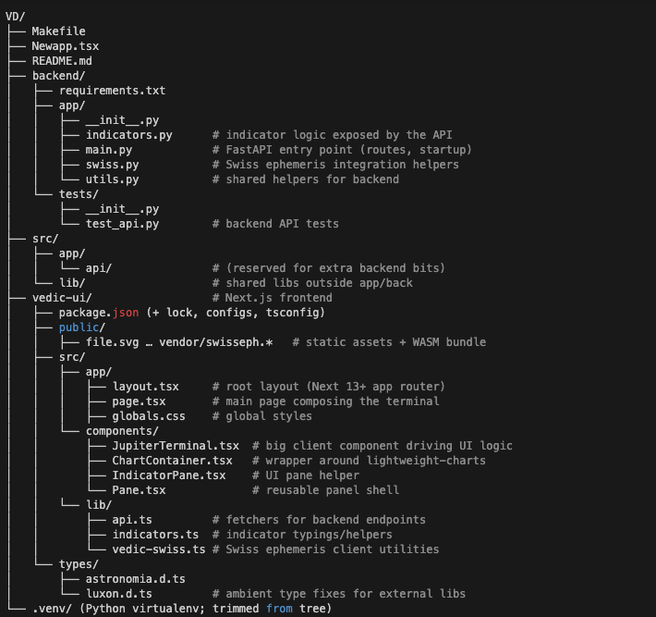

At a glance:
- backend/ holds the FastAPI service you’re running (with Swiss Ephemeris integration).
- vedic-ui/ is the Next.js app; all client work lives under src/ (React components, styling, front-end data layer).
- Top-level src/ is currently a placeholder for any shared code outside backend/UI.
- The virtualenv and skipped folders (node_modules, .git, .next) aren’t shown to keep the tree readable.
Sure—here’s a deeper walkthrough of the two big pieces (frontend and backend) so you know exactly where responsibilities live and how data flows.
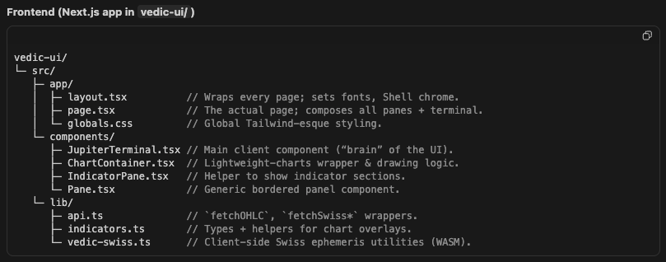
A quick tour:
- page.tsx (server component) orchestrates location inputs, tabs, panes, and mounts <JupiterTerminal/>. It handles:
  - Storing location/tz/date state; passes it into the terminal.
  - Tabbing (“MAIN / LIST / LOCATION”) without unmounting.
  - Collating Swiss event tables (ingress, combustion, stations, etc.).
  - Prefetching Swiss monthly data when the range changes.
- JupiterTerminal.tsx (client) is the workhorse:
  - Fetches OHLC data with fetchOHLC.
  - Manages filters, dropdowns, toggles for event overlays.
  - Keeps range inputs (eventRangeStart/End, lagnaRange...) in state.
  - Converts Swiss monthly events into:
    - chart markers (visible icons on candles),
    - vertical event lines (via eventLines to ChartContainer),
    - text tables in the LIST tab.
It also builds overlayEventLines to draw the thin vertical spines you see and ensures only true sign changes trigger ingress markers.
- ChartContainer.tsx wraps lightweight-charts:
  - Instantiates the chart (candles, volume).
  - Accepts the markers + event lines from JupiterTerminal.
  - Maintains drawing tool state (trend lines) and crosshair callbacks.
  - The recent changes keep vertical spines aligned while panning/zooming.
- Supporting pieces:
  - Pane.tsx gives every panel the same look.
  - IndicatorPane.tsx shows additional panels (LOG, DATA STATUS, etc.).
  - lib/api.ts centralizes REST calls so the terminal just calls fetchSwissMonthly, fetchSwissHorizon, etc.
  - lib/vedic-swiss.ts is ready for in-browser Swiss calculations if you ever load WASM client side (currently server supplies data).

Backend (FastAPI service in backend/)
backend/
├─ app/
│ ├─ main.py // FastAPI app setup; router + startup tasks.
│ ├─ swiss.py // Swiss ephemeris logic (Swiss Ephemeris or PySwiss).
│ ├─ indicators.py // Any indicator computations you expose.
│ └─ utils.py // Shared helpers (time conversions, caching, etc.).
├─ requirements.txt // Dependencies: fastapi, swisseph, pandas, etc.
└─ tests/
└─ test_api.py // pytest suite hitting API endpoints.
Key routes (in main.py):
- GET /api/ohlc: returns OHLC candles for the symbol/interval/period requested by the React app.
- POST /api/swiss/horizon: given lat/lon/tz, returns lagna & moon events (short horizon window).
- POST /api/swiss/monthly: given month/tz, returns monthly ingress/combustion/stations/velocity tables.
- CORS is enabled so the Next.js front end can call it locally—hence the OPTIONS preflight logs you’ve seen.
All Swiss-specific work happens in swiss.py. That module wraps the Swiss Ephemeris (WASM/Python) to produce the event rows consumed by the UI. indicators.py is used if you want backend-side indicator calculations beyond the chart (right now the chart is mostly managed on the client).

Data flow
- UI loads → JupiterTerminal fires fetchOHLC (candles) and fetchSwiss* (event tables). Backend responds with JSON.
- Events are filtered and cached by month (ingressEventsByMonth, etc.) on the page side so the MAIN chart and LIST tables share data.
- The MAIN tab renders <ChartContainer> with:
  - Candle series (OHLC).
  - Markers derived from event rows.
  - eventLines for the vertical spines (only true sign changes for ingress).
- The LIST tab displays the same data in tables, allowing month navigation and CSV export.
Because the backend only exposes JSON and never serves a root page, those GET / 404 logs are normal.
Use this for the backend first.
python3 -m venv .venv
source .venv/bin/activate
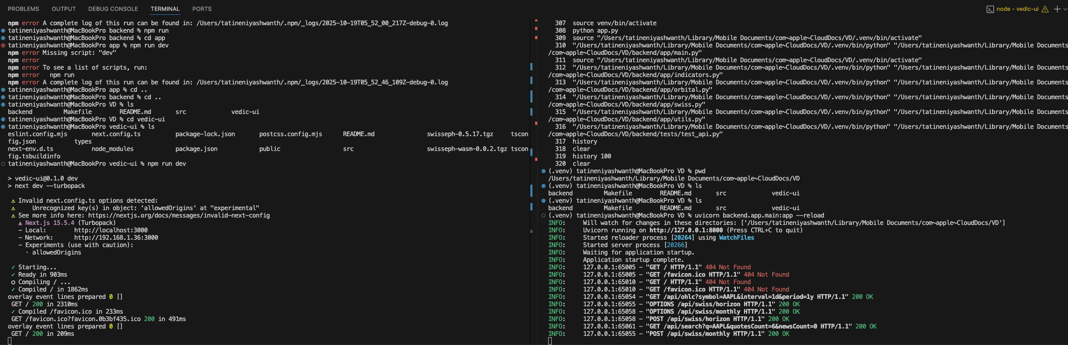

Summary
I've successfully integrated Google OAuth authentication and Stripe payment processing into your Vedic Trading Terminal! Here's what was implemented:

🔐 Authentication Features
- Google OAuth Sign-In
  - Beautiful sign-in page at /auth/signin
  - Secure session management with NextAuth
  - Error handling page for authentication issues
- Session Provider
  - Wrapped the entire app with authentication context
  - User session persists across page reloads
- Navigation Integration
  - Added "Sign In" / "Account" button to main header
  - Shows user profile picture when logged in
  - Seamless navigation to account page

💳 Payment & Subscription Features
- Account Management Page (/account)
  - User profile display with Google profile picture
  - Subscription status tracking (active/inactive)
  - Sign out functionality
  - Upgrade to premium ($29/month subscription)
- Stripe Integration
  - Checkout session creation
  - Customer portal for managing subscriptions
  - Cancel/update subscription options
  - Real-time subscription status display
- API Routes Created
  - /api/auth/[...nextauth] - Authentication endpoints
  - /api/checkout - Create Stripe checkout session
  - /api/portal - Access Stripe customer portal
  - /api/subscription - Get current subscription status
  - /api/webhooks/stripe - Handle Stripe webhook events

📁 Files Created
- src/lib/auth.ts - NextAuth configuration
- src/lib/stripe.ts - Stripe utilities
- src/app/auth/signin/page.tsx - Sign-in page
- src/app/auth/error/page.tsx - Error page
- src/app/account/page.tsx - Account management
- src/components/SessionProvider.tsx - Session context
- .env.example - Environment variables template
- AUTH_SETUP.md - Complete setup guide

🚀 Next Steps
To get this working, you need to:
- Set up Google OAuth credentials (see AUTH_SETUP.md)
- Set up Stripe account and get API keys
- Create a .env.local file with your credentials:
- cp .env.example .env.local
- # Then fill in your actual values
- Restart the dev server after adding environment variables

🎨 Premium Features Display
The account page shows a nice list of premium features:
- Advanced Vedic astrology events
- Real-time market data
- Custom indicators and drawings
- Priority support
All with a sleek terminal-style UI matching your existing design!

The integration is complete and ready to use once you configure the environment variables. Check AUTH_SETUP.md for the detailed step-by-step setup guide.

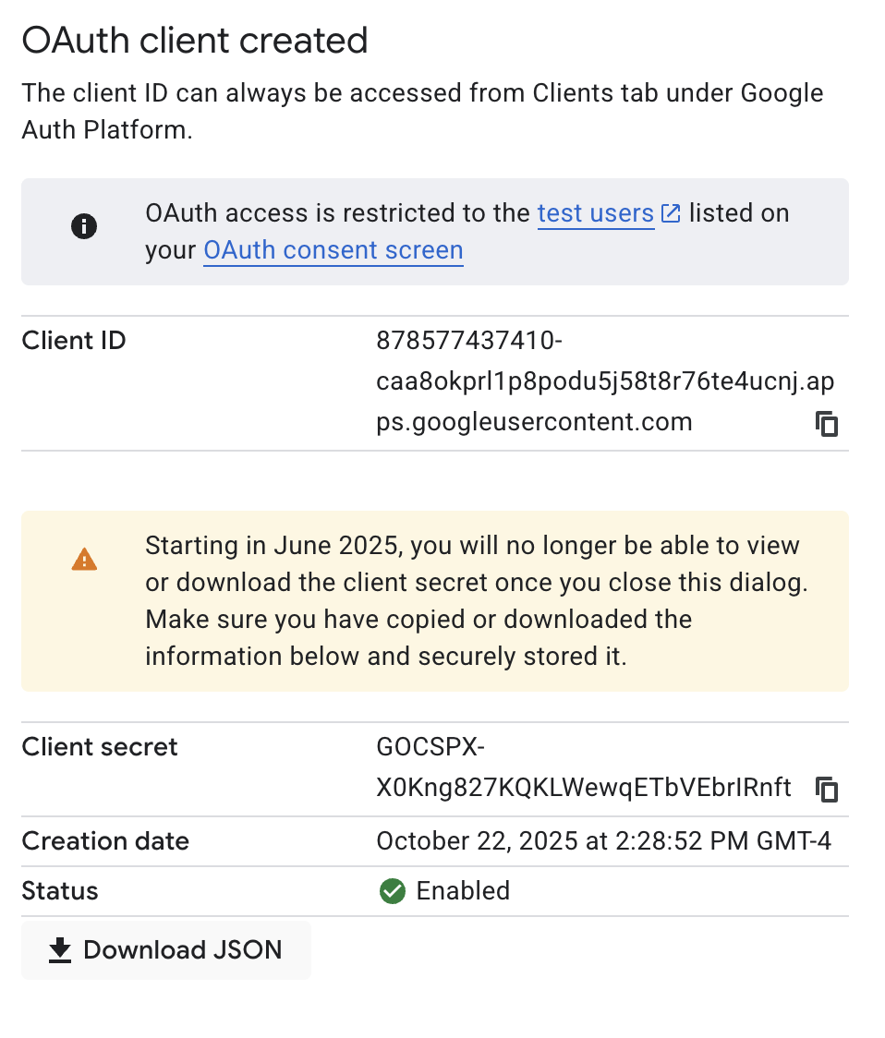

Stripe -
publishing key - pk_test_51SL7Q3G9xbtc5muZkjQHzT8ip8CQtIOcDTtI4WDgkLlZqhCuBipKGB01mKmJxMjQWo5552xRrVHAGSQ8M38YmIdT00viqYce23
sk_test_51SL7Q3G9xbtc5muZV5aFS2h8VNsKtvR4awaIan2dijBIzLpq3L8T3qs92IHmGuEeoLf9tOT0NEJxQVy8X3s3nhQe00EueeSS1O
Your Backend Architecture:
Backend (FastAPI - Python):
- 📍 Location: /backend/
- 🚀 Framework: FastAPI
- 📊 Features:
  - Vedic astrology calculations (Swiss Ephemeris)
  - Candlestick/market data fetching (yfinance)
  - Orbital calculations
  - CORS enabled for frontend communication
Frontend (Next.js - TypeScript):
- 📍 Location: /vedic-ui/
- ⚛️ Framework: Next.js 15 with React 19
- 💳 Features:
  - UI/UX (JUPITER terminal)
  - Stripe integration (subscriptions)
  - NextAuth (Google OAuth)
  - API routes for auth & payments

Updated Deployment Strategy:
Since you have two separate services, here's the best approach:

Option 1: Deploy Both Separately (Recommended)
Frontend (Vercel):
- Deploy Next.js app to Vercel
- Configure environment variables (Stripe, NextAuth, Backend API URL)
Backend (Railway/Render/Fly.io):
- Deploy FastAPI backend separately
- Get production URL (e.g., https://jupiter-api.railway.app)
- Configure CORS to allow your frontend domain
Benefits:
- Independent scaling
- Specialized hosting for each stack
- Clear separation of concerns

Option 2: Deploy as Monorepo (Vercel)
You could deploy both on Vercel, but you'd need to:
- Configure Vercel to handle both Next.js and Python
- Use Vercel Serverless Functions for FastAPI endpoints
- More complex setup

My Recommendation:
Best approach for your setup:
- Deploy Backend First (Railway or Render):
  - Easier Python deployment
  - Get your backend API URL
  - Free tier available
- Deploy Frontend (Vercel):
  - Add backend API URL to env vars
  - Configure Stripe & Google OAuth
  - Get frontend URL for webhooks
- Configure Services:
  - Update CORS in backend with frontend URL
  - Set up Stripe webhooks
  - Configure Google OAuth redirect URIs
Backend is live on - https://jupiter-terminal-production.up.railway.app/
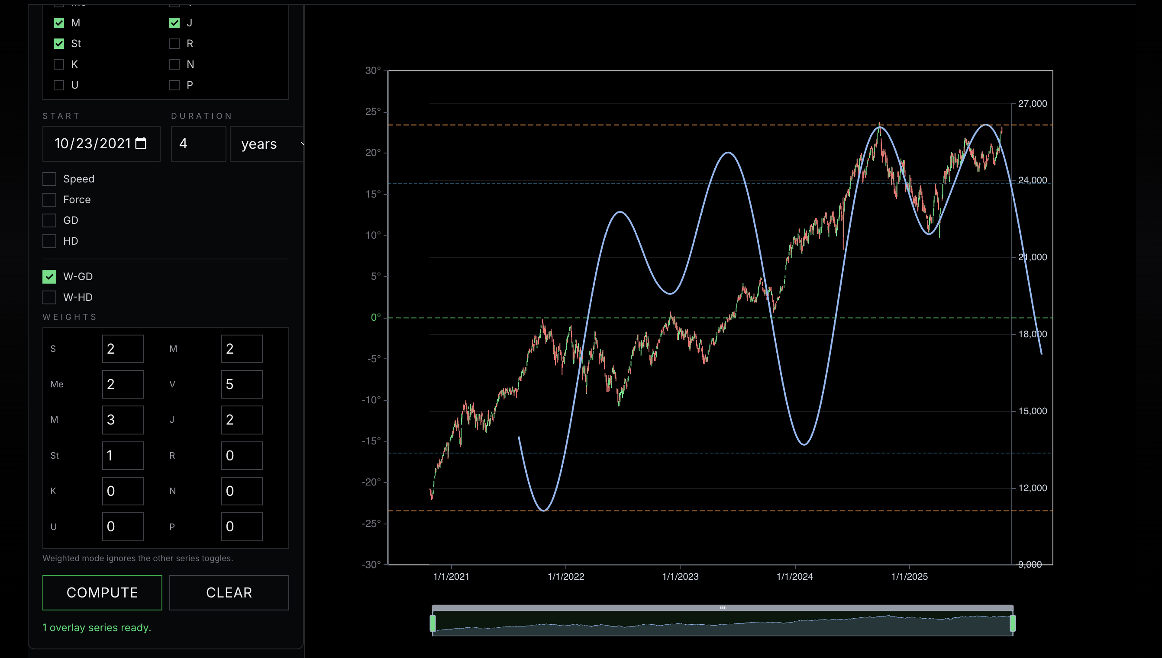
- force
- speed
- not loading fast
- planetary lines
- try pada for lagna / not 15* and 30*
- change the ahamsa to BV ramana
future -
-where we planets stand today
-more research on add declinations and playing with the weights.

